Electrical Research
By Artjom Timofejev

The Battery – The Powerhouse of your RC Car
The battery is the “fuel tank” of the RC car that stores and provides all the necessary electrical energy to make your RC car move. So, it has two important parameters.
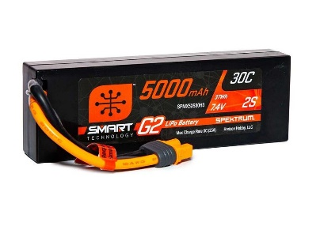
Voltage determines how fast the electronics and motors in RC will operate. More voltage means the motor to spin faster. Though, there are limits – feed a component too much voltage and things will fry out immediately. Also, even if battery says 7.4V that will be it 50% charge its max charge will be around 8.4V
Capacity determines how long your battery will last before it needs recharging. The higher the mAh, the longer the run time. For example, 5000mAh battery that has a 60-amp draw placed on it should theoretically last 5000/60= 83 minutes, but usually it is enough for 20-30 min run time due to system inefficiencies, but higher mAh equals longer runs either way.

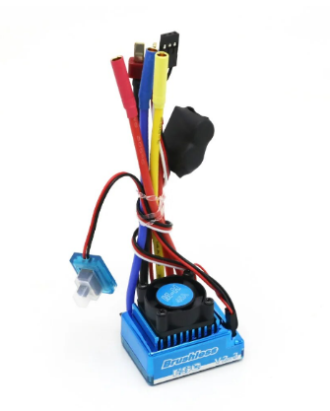
The ESC (Electronic Speed Controller)

The battery gets plugged into the ESC, which controls how much of the battery’s power gets sent to the motor. It regulates the motor’s speed by adjusting the amount of current flowed. At full throttle, maximum amps flow from the battery to the motor via the ESC. The ESC we are using is fully programmable, allowing you to tweak settings like acceleration curves, braking strength, drag brake forces and more.

Brushless Motor KV Rating
Brushless motor (the one we are using) have a KV rating, which specifies the number of RPM it spins per volt supplied, so if a motor has a KV rating of 3000KV given 8.4 volts, the calculation is:
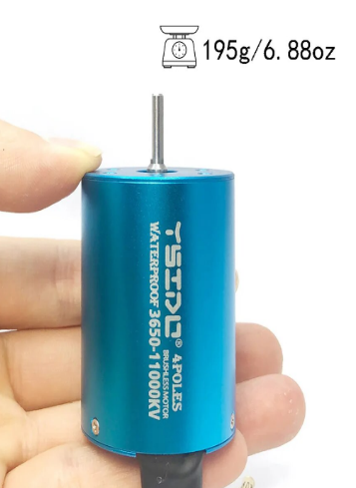
8.4 volts x 3000KV = 25,200 RPM!
That is over 400 revolutions per second at full power! More KV equals more speed, but there are always trade-offs with low-end torque, efficiency, and endurance to consider. With brushless systems, you want the KV matched with the gearing and battery voltage for optimal efficiency, but some tend to not take it in mind and throw whatever they love into it.

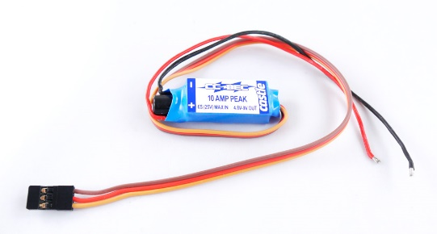
BEC (Battery Elimination Circuit)
One of the especially important parts in RC Car as high-power servos need more current than a typical ESC’s BEC can provide. When this happens, you will experience glitching or stuttering behaviour as voltage momentarily drops. BEC solves this by taking raw battery power as input, then stepping it down to 6V for output to high-demand electronics. It is usually integrated into ESC.

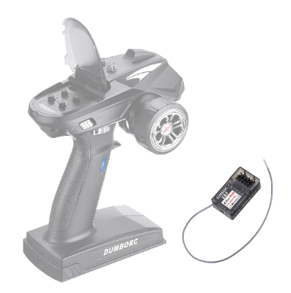
The Radio Receiver
Controller’s signals are sent via radio frequencies to the receiver, which relays the commands to the ESC and servo accordingly. This allows you to wirelessly control throttle and steering from a distance. The receiver requires only a small amount of current to operate, which it draws from the ESC’s BEC circuit mentioned earlier.

The Steering Servo
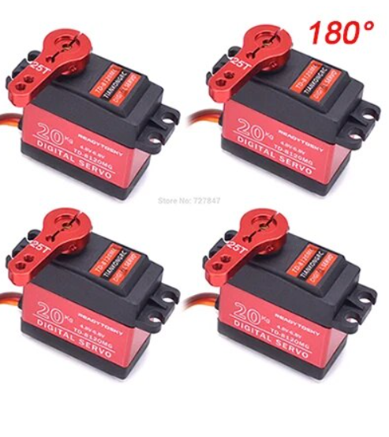
The receiver takes your steering commands and passes them to the servo, which then moves the front wheels or any other servo accordingly. The amount of force a servo can apply is expressed in kg/cm or oz/in. For example, a “25kg” servo can provide 25 kg of force on a 1 cm arm from the output shaft. Higher quality servos have metal gears and stronger motors to resist stripping under heavy loads, as well as adjustable turning point. The servo connects to the receiver’s signal line to receive input, and the receiver’s power lines to get operating current. Usually, servo programming (strength, speed, attach angle etc.) is done through remote control, but can also be done through programming card.

Reference
By Chris Williams, Updated On12 01 2024, Information taken
RC Car Battery Guide What You Need To Know (carmagazine.co.uk)

